**Project Report**

ON

**“Survey Form (**Mental Stress**)”**

#### using HTML, CSS, JavaScript

SUBMITTED IN PARTIAL FULFILLMENT OF THE REQUIREMENT FOR THE AWARD

OF THE DEGREE OF BACHELOR OF ENGINEERING

### COMPUTER SCIENCE & ENGINEERING



**Submitted to: Er Navjot Singh and Er Prince Sharma**

**SUBMITTED BY:**

##### Lawanya Arora (20bcs5131)

###### DEPARTMENT OF COMPUTER SCIENCE & ENGINEERING CHANDIGARH UNIVERSITY, GHARUAN

**CONTENTS**

**Topic Page No**

***Candidate’s Declaration i***

Abstract ii

Acknowledgement iii

About the course iv

CHAPTER 1 INTRODUCTION 6-8

* 1. Introduction 6
  2. software and hardware required 7

CHAPTER 2 SRS 11-12

3.1 SRS

CHAPTER 3 13-16

4.1 ER diagram

CHAPTER 5 Material and methodology 17-20

* 1. Proposed Work 17
  2. Team Work 20

CHAPTER 6 Result and Snapshots 21-35

* 1. Result 21
  2. Snapshot 23

CHAPTER 7 Conclusion and Future work 36-39

**7.1 Conclusion**

REFERENCES 40

**CHANDIGARH UNIVERSITY,GHARUAN,MOHALI CANDIDATE'S**

**DECLARATION**

##### I LAWANYA ARORA hereby declare that I have undertaken Summer Training and developed project titled “ Survey Form (Mental Stress) during a period from June to

July 2021 in partial fulfillment of requirements for the award of degree of B.E (COMPUTER SCIENCE & ENGINEERING) at CHANDIGARH UNIVERSITY

GHARUAN, MOHALI. The work which is being presented in the training report submitted to Department of Computer Science & Engineering at CHANDIGARH UNIVERSITY GHARUAN, MOHALI is an authentic record of training work.

Student details and Signatures

Lawanya Arora (20bcs5131)

Signature of Internal Examiner Signature of External Examiner

## Abstract

##### Our Aim is to design and create a survey form on MENTAL STRESS. This web page is develop to provide best travelling services to the customers and travel agents. We have developed tours and travel survey form and landing page to provide a great platform where a tourist can find their love to travel and provide us with valuable customer insights. This system also helps to promote responsible and interesting tourism so that people can enjoy their holidays at their favorable places. This system also helps to develop tourism with different cultures so that they enrich the tourism experience and build pride. We develop this system to create and promote forms of tourism that provide healthy interaction opportunities for tourists and locals and increase better understanding of different cultures, customs, lifestyles, traditional knowledge and believes.

###### ACKNOWLEDGEMENT

We would like to express our deep and sincere gratitude to our Project In charge **ER Navjot Singh and Er Prince Sharma** for giving us the opportunity to do the project and providing valuable guidance throughout this research. Their dynamism, vision and exquisite efforts have deeply inspired us. They taught us the methodology to carry out the research and to present the research work as clearly as possible. It was a great privilege for us to study and work under their guidance.

We owe the completion of my project to our project Mentor for his continuous support and guidance

# **About the Course**

Do you realize that the only functionality of a web application that the user directly interacts with is through the web page? Implement it poorly and, to the user, the server-side becomes irrelevant! Today’s user expects a lot out of the web page: it has to load fast, expose the desired service, and be comfortable to view on all devices: from desktop computers to tablets and mobile phones.

In this course, we will learn the basic tools that every web page coder needs to know. We will start from the ground up by learning how to implement modern web pages with HTML and CSS. We will then advance to learning how to code our pages such that its components

rearrange and resize themselves automatically based on the size of the user’s screen. You’ll be able to code up a web page that will be just as useful on a mobile phone as on a desktop computer. No “pinch and zoom” required! Last but certainly not least, we will get a thorough introduction to the most ubiquitous, popular, and incredibly powerful language of the web: Javascript. Using Javascript, you will be able to build a fully functional web application that utilizes Ajax to expose server-side functionality and data to the end user

***Project Description***

**CHAPTER 1**

**INTRODUCTION**

##### The Survey form on MENTAL STRESS is a web based application form . The main purpose of this SURVEY FORM is to provide a convenient way for Any individual to look into their stress level , mental health and any sort of issue related to mental health (if any). The objective of this project is to develop a system that automates the processes and activities for the people dealing with stress in day to day life and could not find any sort of help to come out of the hole. In this project, We will make an easier task of knowing to how much stress an individual is dealing with , how badly or normally its laying its affects on mental health . In the present system , we provided a survey form , in which several health related questions and stress related questions have been asked to who so ever would have approached here to look or search for solution for their mental stress which eventually will leads to the links or contact details of concerned and authorized doctors who will not only help you with your issues related to mental health but also guide you how one can lay a healthy , stress free and fun lifestyle .

**1.2 Software and Hardware tools required for Project:-**

*Software:*

**HTML**

HTML stands for Hyper Text Markup Language**.** Itis the standard markup language for creating Web pages**.** It describes the structure of a Web page**.**It consists of a series of elements. HTML elements tell the browser how to display the content**.**HTML elements label pieces of content such as "this is a heading", "this is a paragraph", "this is a link", etc.

**Hypertext Markup Language** (**HTML**) is the standard markup language for documents designed to be displayed in a web browser. It can be assisted by technologies such as Cascading Style Sheets (CSS) and scripting languages such as JavaScript.

**CSS**

CSS stands for Cascading Style Sheets. CSS describes how HTML elements are to be displayed on screen, paper, or in other media. CSS saves a lot of work. It can control the layout of multiple web pages all at once. External stylesheets are stored in CSS files

**JAVASCRIPT**

**JavaScript** often abbreviated as **JS**, is a programming language that conforms to the ECMAScript specification.[7] JavaScript is high-level, often just-in-time compiled, and multi-paradigm. It has curly- bracket syntax, dynamic typing, prototype-based object-orientation, and first-class functions.

Alongside HTML and CSS, JavaScript is one of the core technologies of the World Wide Web.[8] JavaScript enables interactive web pages and is an essential part of web applications. The vast majority of websites use it for client-side page behavior,[9] and all major web browsers have a dedicated JavaScript engine to execute it.

**PHP**

**PHP** is a general-purpose scripting language that is especially suited to web development. It was originally created by Danish-Canadian programmer Rasmus Lerdorf in 1994; the PHP reference implementation is now produced by The PHP Group. PHP originally stood for *Personal Home Page*,[7] but it now stands for the recursive initialism *PHP: Hypertext Preprocessor*.

**MY SQL**

SQL is a standard language for accessing and manipulating databases. SQL stands for Structured Query Language. SQL lets you access and manipulate databases. SQL became a standard of the American National Standards Institute (ANSI) in 1986, and of the International Organization for Standardization (ISO) in 1987

SQL can execute queries against a database, retrieve data, insert records in a database, update records

,delete records, create new databases, create new tables in a database, create stored procedures in a database, create views in a database, set permissions on tables, procedures, and views

*Hardware:*

* Processor (CPU) with 2 gigahertz (GHz) frequency or above A minimum of 2 GB of RAM
* Monitor Resolution 1024 X 768 or higher
* A minimum of 20 GB of available space on the hard disk .Internet Connection Broadband (high-speed) Internet connection with a speed of 4 Mbps.

**CHAPTER 2**

**SRS (SOFTWARE REQUIREMENT SPECIFICATION)**

A software requirements specification (SRS document) describes how a software system should be developed. Simply put, an SRS provides everyone involved with a roadmap for that project.It offers high- grade definitions for the functional and non- functional specifications of the software, and can also include use cases that illustrate how a user would interact with the system upon completion. An SRS should have enough information for developers to complete the software described. It not only lays out the description of the software under development but also the purpose it will serve: what the software is supposed to do and how it should perform.

###### CHAPTER 3

**4.1 ER DIAGRAM**

ER Model is represented by means of an ER diagram. Any object, for example, entities, attributes of an entity, relationship sets, and attributes of relationship sets, can be represented with the help of an ER diagram.

###### Entity

Entities are represented by means of rectangles. Rectangles are named with the entity set they represent.

###### Attributes

Attributes are the properties of entities. Attributes are represented by means of ellipses. Every ellipse represents one attribute and is directly connected to its entity (rectangle).

If the attributes are **composite**, they are further divided in a tree like structure. Every node is then connected to its attribute. That is, composite attributes are represented by ellipses that are connected with an ellipse.

**Multivalued** attributes are depicted by double ellipse.

**Derived** attributes are depicted by dashed ellipse.

### Relationship

Relationships are represented by diamond-shaped box. Name of the relationship is written inside the diamond-box. All the entities (rectangles) participating in a relationship, are connected to it by a line.

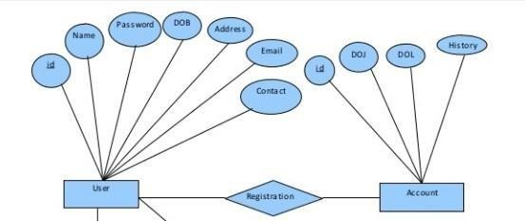

#### CHAPTER 4

**MATERIAL AND METHODOLOGY**

Several materials are used to built this project . Certain software interfaces are used like window 8/10 , 4gb ram/ 255gb hp .Technologies are also used like JAVA, MY SQL, PHP, for full stack development tools.

* First of all you have to log in to the system.
* New users will sign up and old users will log in to the system.
* Then they will be directed to the home-screen where they can see the list of top cars. Here they can search for the cars they want to know about.
* Users can read reviews about the cars after clicking to the read review button. Users can add reviews after clicking the add review button.
* Users will also get informed about the rating of the review based on previous customers’ reviews.
  1. **PROJECT DESIGN**

This describes the proposed system, explaining how modules and components integrate and Communicate to bring about the working application of the proposed system. The website

design is developed to satisfy the requirement of modern system architecture including computational structures andmodel training algorithms. The website design will also capture the major functional building blocks needed to understand the process of building a system.

#### CHAPTER 5

**RESULTS AND SNAPSHOTS**

**6.1 Result**

Therefore, after implementing all the mentioned libraries as well as software tools, we finally full- fledge website where users can fill our survey form and can read about it in detail.

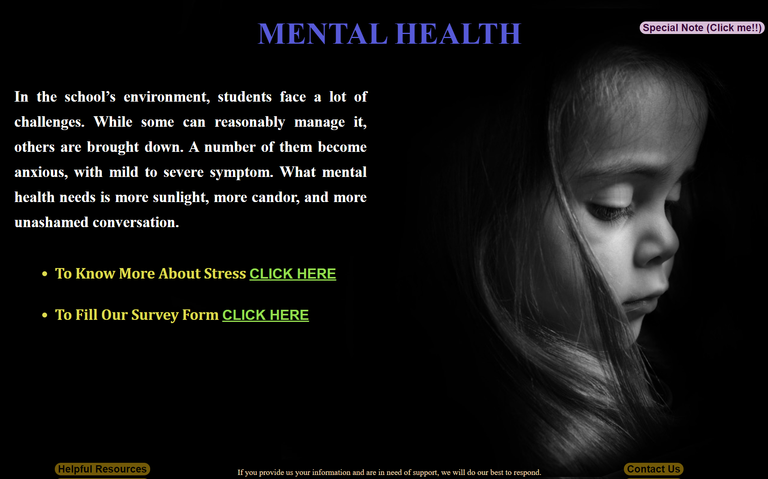

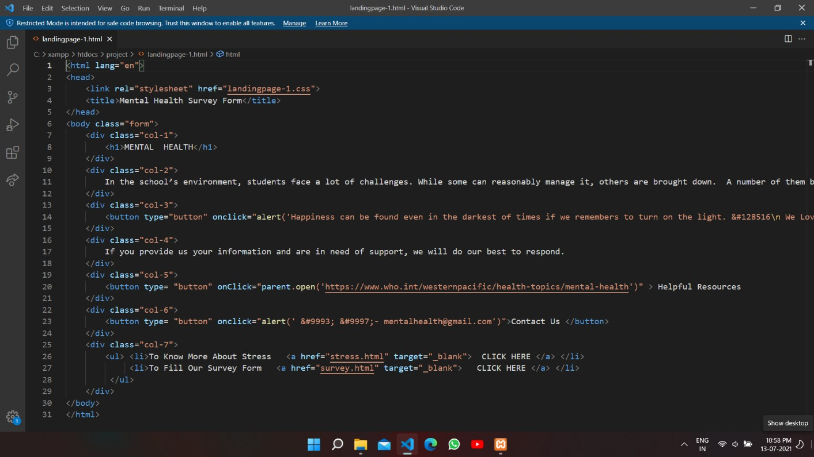

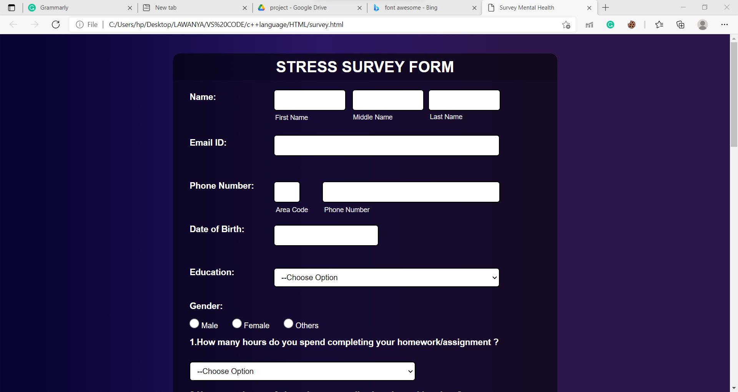

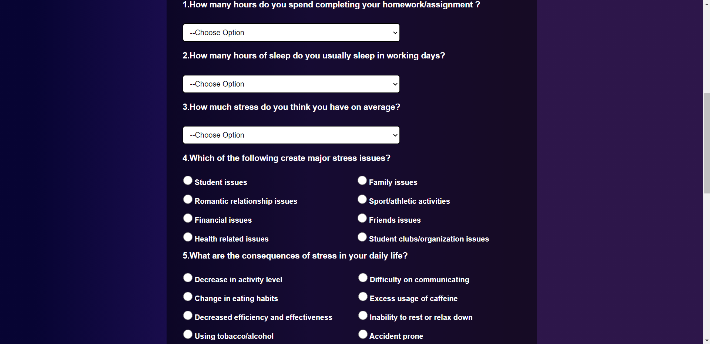

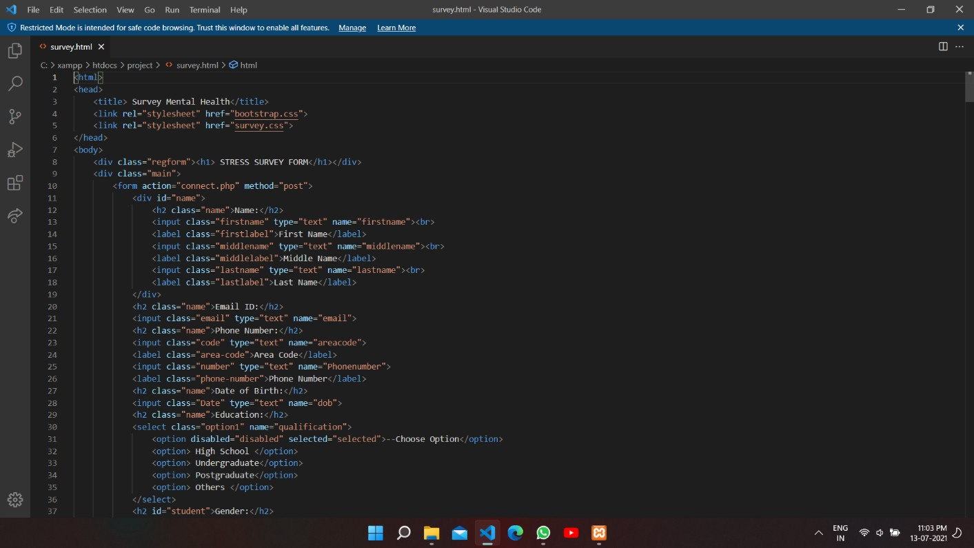

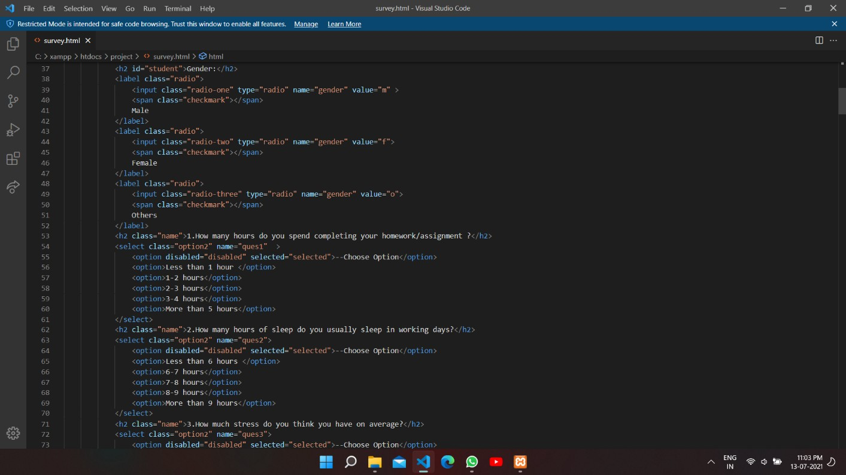

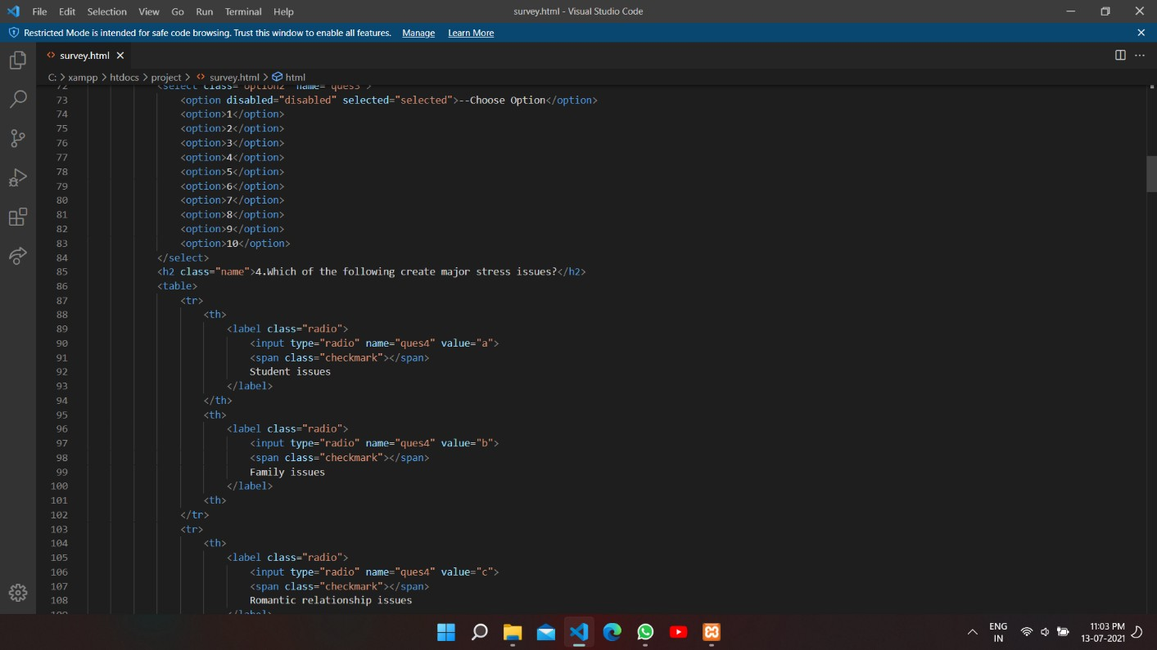

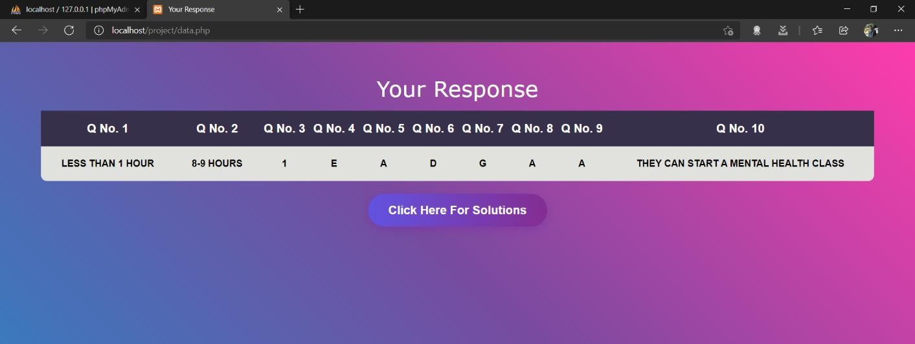

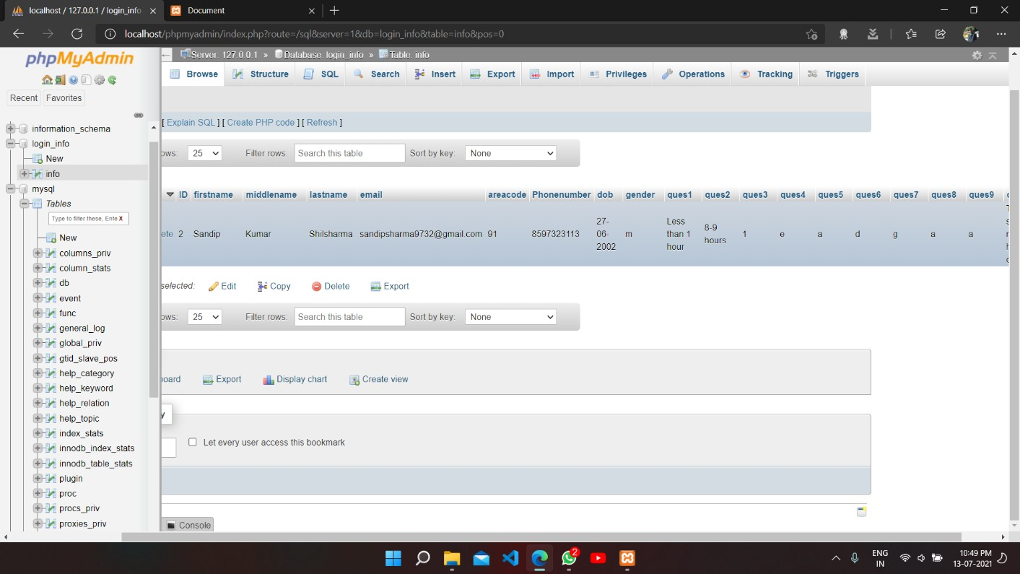

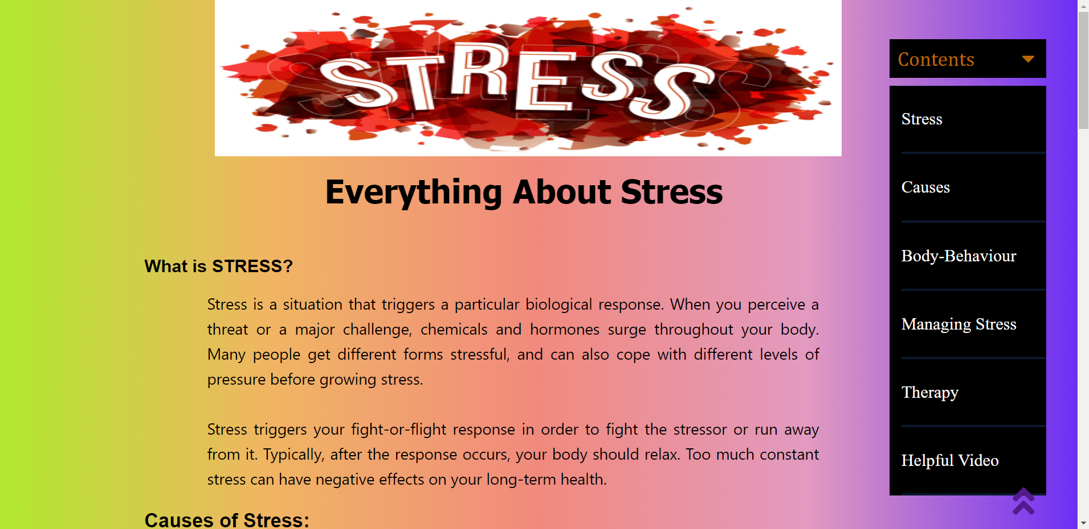

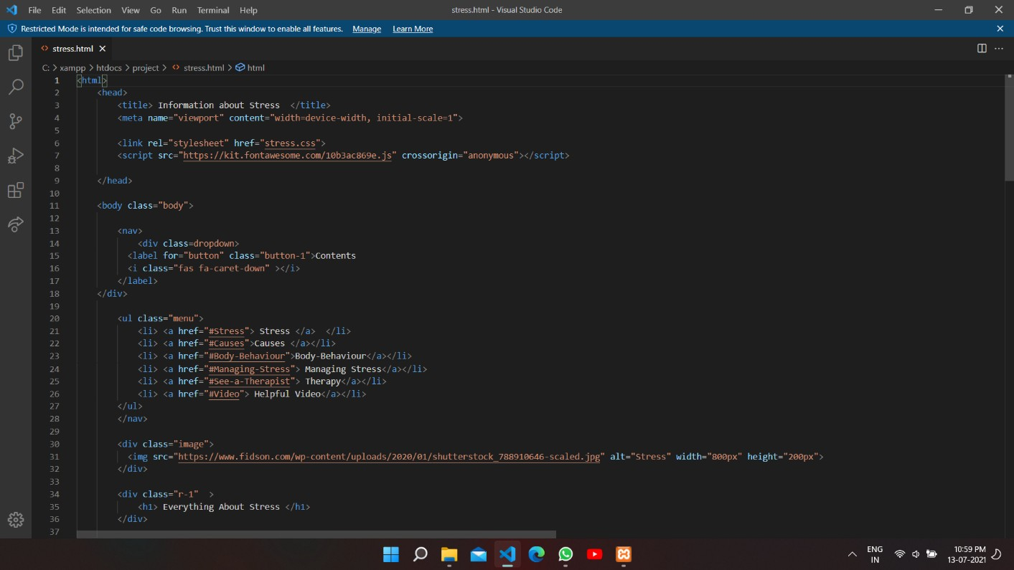

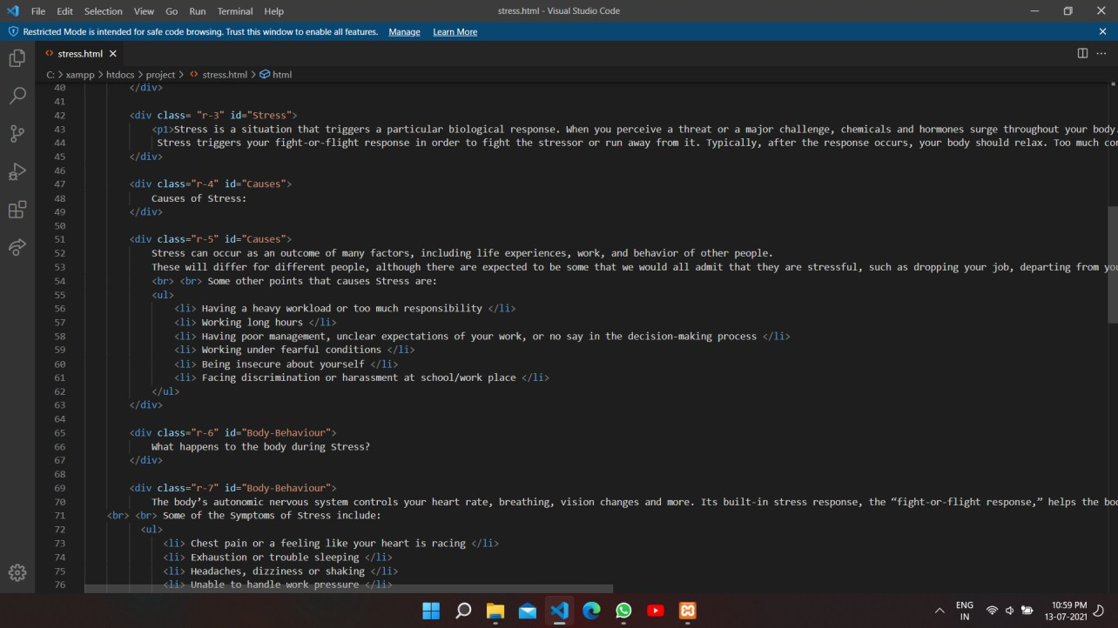

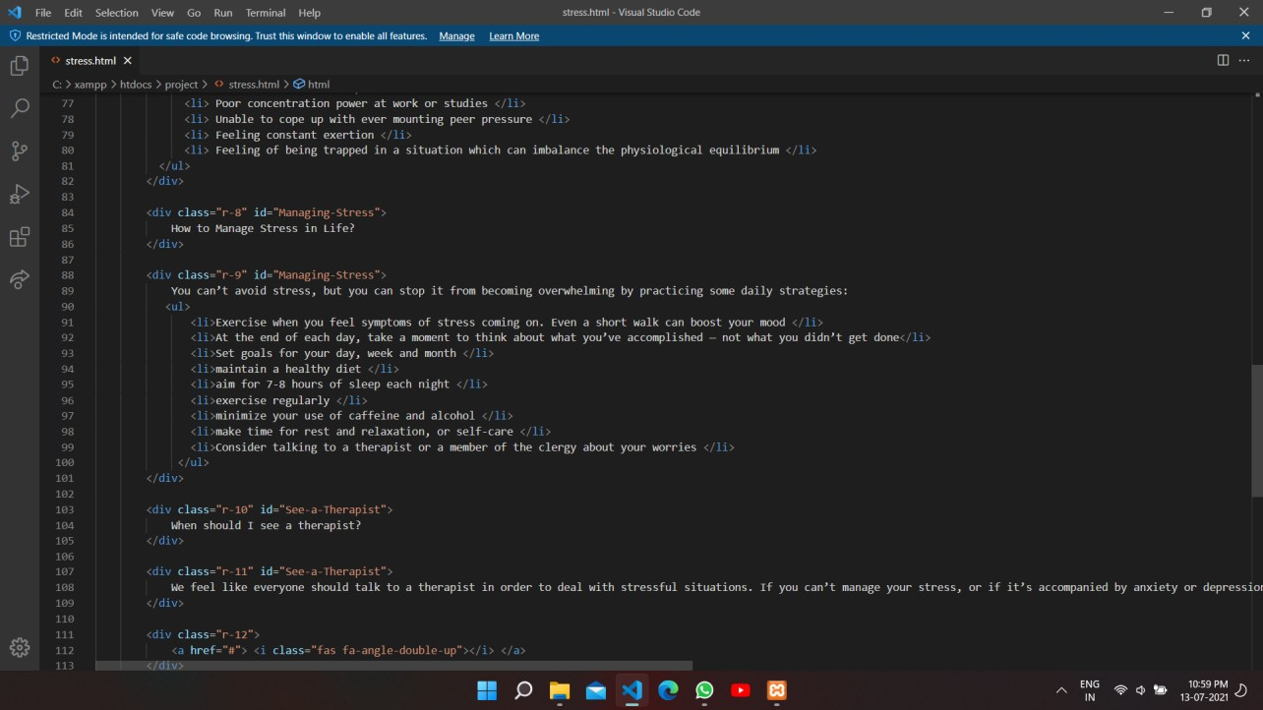

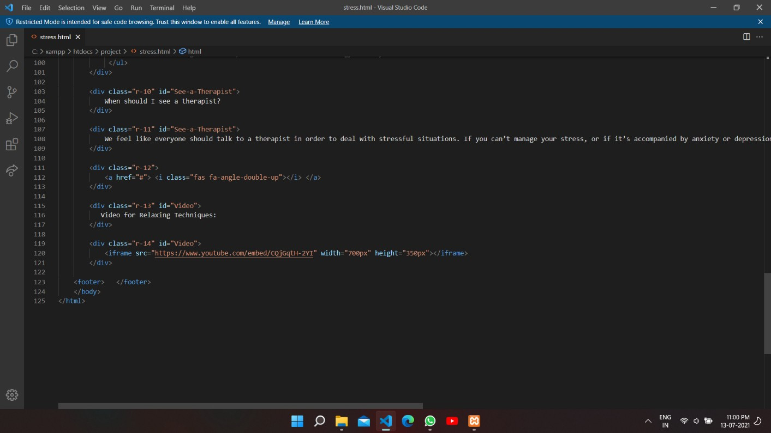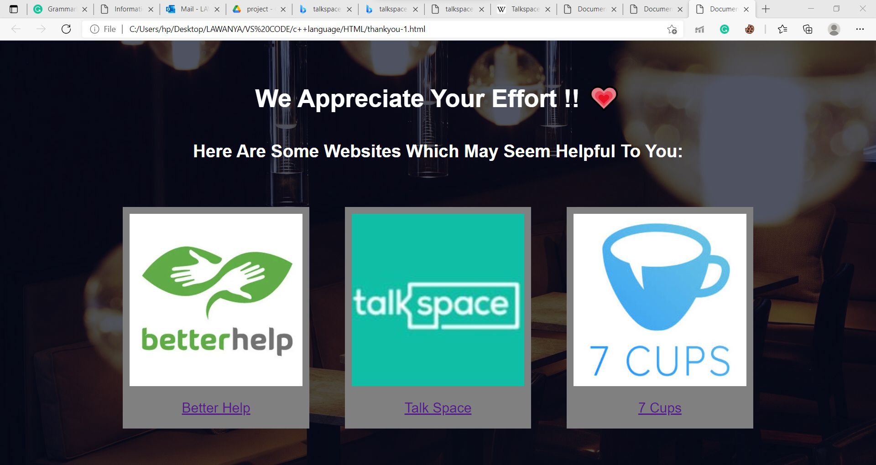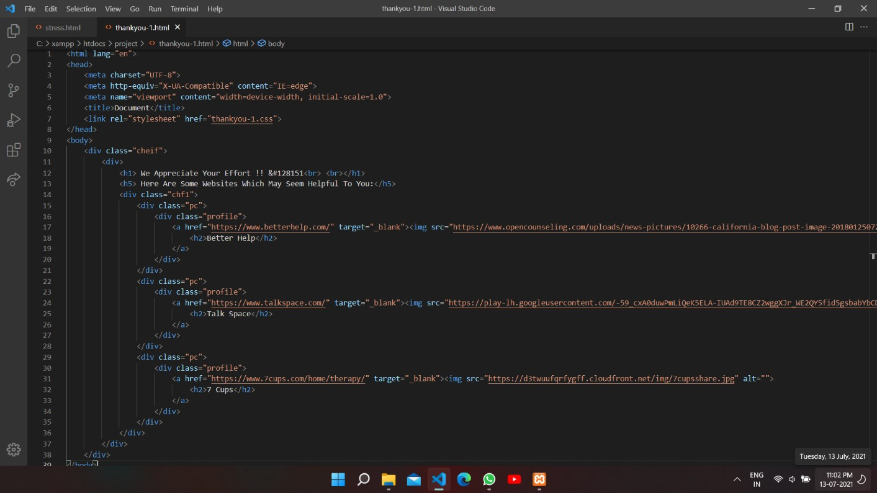

**Chapter 7 CONCLUSION AND FUTURE SCOPE**

Our project is only a humble venture to satisfy the needs to manage their project work. Several user friendly coding has also been adopted. The objective of the software planning is to provide a framework with a limited project completion time frame at the beginning of the project and should be updated on a regular basis.

HTML and CSS are actually surprisingly large topics, who would have thought? If you’ve made it this far, though, you’re more than well on your way to front end development magic. You should be significantly more comfortable breaking down a webpage into its component pieces and then coding them with HTML and CSS. You have the tools necessary to identify an effective visual layout and then bring it to fruition. There are still plenty of ways you can make your workflow better or improve your knowledge of best practices (so don’t stop learning!), but you’ve got everything you need to build beautiful websites. Now that you’ve finished this course, you are probably chomping at the bit for the final piece of the puzzle which will empower you to make everything dynamic.

### REFERENCES

##### W3Schools

* + 1. Freecodecamp.org
    2. Javascript.info
    3. Php.net
    4. Csstricks.com
    5. Codeacademy.com
    6. Pexels.com
    7. Pixabay.com